**Lab – 33: Working with the** **Cloud App Security and Cloud Discovery dashboard.**

**Objective:** The objective of this lab is –

* To learn how to work with Cloud App Security and Cloud Discovery dashboard.

The Cloud App Security dashboard provides you with an overview of activities and features such as - open alerts, activity violations, content violations, an activity map that plots where user activity originates and connected app usage trends in your cloud environment.

And, The Cloud Discovery dashboard is designed to give you more insight into how cloud apps are being used in your organization. It provides an at-a-glance overview of what kinds of apps are being used, your open alerts, the risk levels of apps in your organization.

So, in this lab we are going to learn how to work on these dashboards.

**Prerequisite:** EMS Enterprise Mobility + Security E5.

**Steps:**

1. To access the Cloud App Security portal, go to <https://portal.cloudappsecurity.com>.

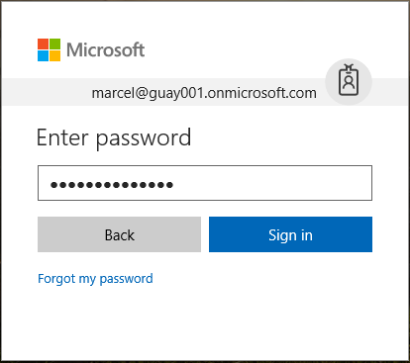

1. When you sign-in to Cloud App Security, a general dashboard will be shown. It shown all the listed applications at the left-hand side. You can click any app to view the dashboard for a specific app.

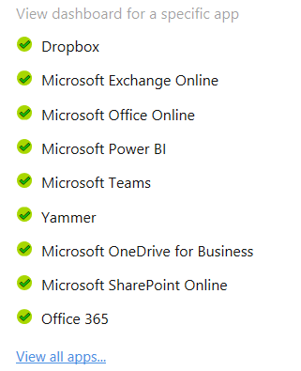

1. The general dashboard section will display – number of activities being monitored, the number of files being monitored, number of accounts being monitored, discovered apps, governance actions taken and user notification sent.

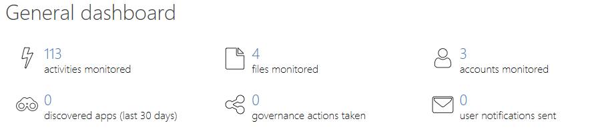

1. Open alerts section will display, the recent alerts that were generated by severity level and by alert type.
2. Activity violations and content violations will be shown.
3. Activity map will show, the locations from where the activities are going on.
4. And, trends graph according to activities and active users will be shown.

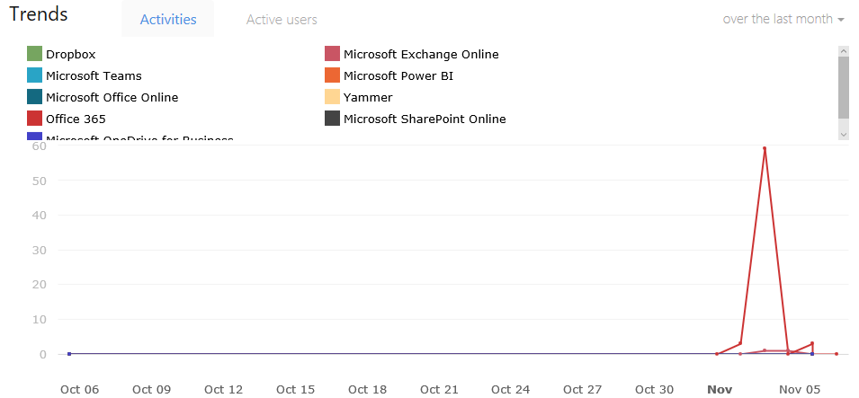

1. Then go to **Discover**, then **Cloud Discovery dashboard** and check for - What cloud apps are being used, to what extent, and by whom? For what purposes are they being used? How much data is being uploaded to these cloud apps? In which categories do you have sanctioned cloud apps, and yet, users are using alternative solutions? For the alternative solutions, do you want to unsanctioned any cloud apps in your organization? Are there cloud apps that are used but not in compliance with your organization’s policy?

You can view the information in 4 tabs – dashboard, discovered apps, IP addresses and users.

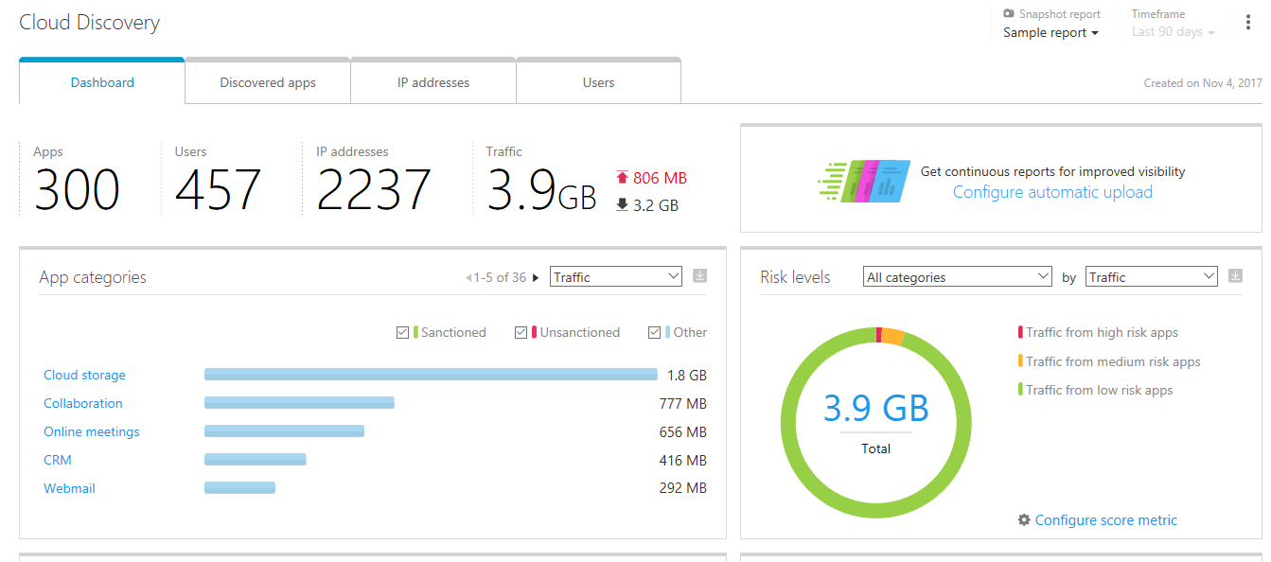

1. From the Dashboard tab, you can get – total number of discovered apps in this report, total number of unique users in this report who are using discovered cloud apps, total number of IP addresses in this report that accessed discovered cloud apps. Total number of upload and download data that is going to and from discovered cloud apps. Amount of uploaded data is red. And amount of downloaded data in black.

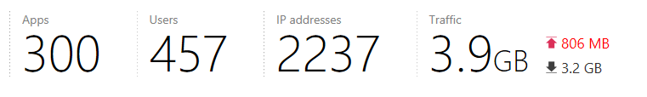

1. Then go to **App categories**. It will show categories of apps like – cloud storage, collaboration, online meetings, CRM, webmail, content management, accounting & finance, customer support, security etc. based on the selection – like – Traffic, apps, users, IP addresses, upload or transactions. It will also show the apps are sanctioned or unsanctioned or other.

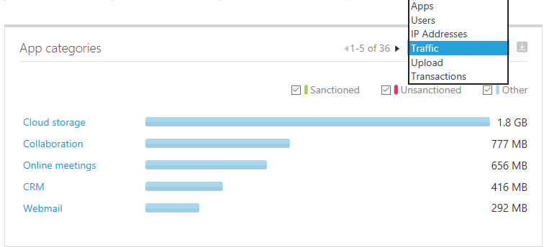

1. Then risk levels will show the traffic from high/medium/low risk apps. You can choose the category by traffic also. Traffic from high risk apps is in red, traffic from medium risk apps in yellow and traffic from low risk apps in green.

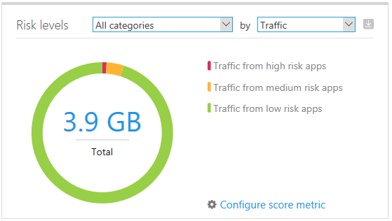

1. Discovered apps shows all the discovered cloud apps like – Microsoft OneDrive, Office 365, Microsoft Skype for business, Box, Microsoft Dynamics, Microsoft Exchange etc. based on sanctioned, unsanctioned, and other category.

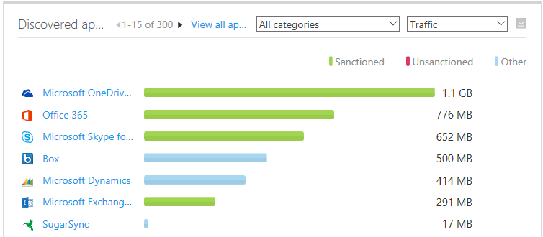

1. Top Users/top IP addresses section will show the email addresses of top users that accessed discovered cloud apps and IP addresses that accessed discovered cloud apps.

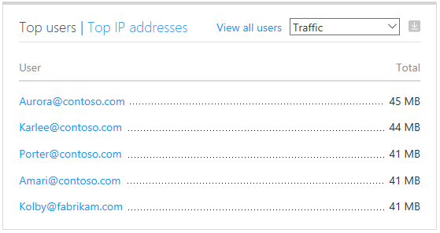

1. Apps headquarters location will show the discovered cloud apps headquarters location.

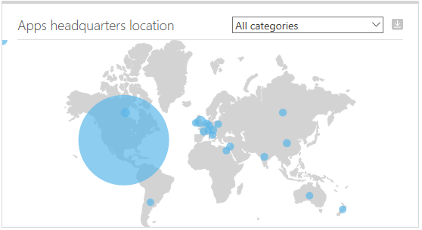

1. Then click **Discovered apps** tab. This will show all the discovered cloud apps like – Microsoft IIS with its score, traffic, upload data, transaction, users, IP addresses, last seen and actions.

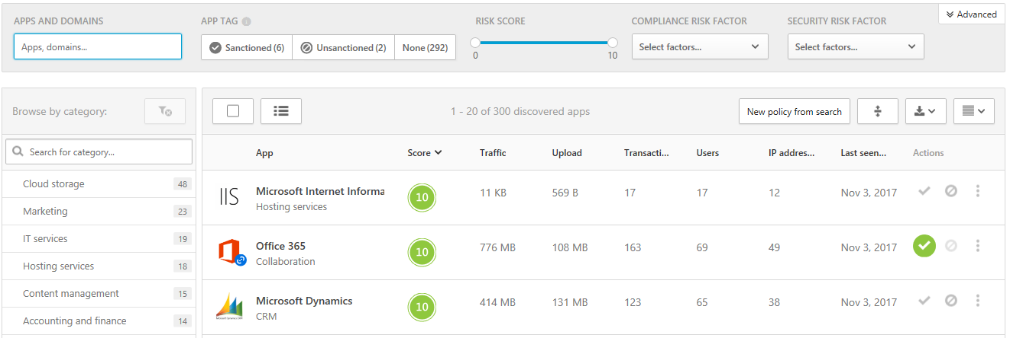

1. You can also click any app to get the complete information about that app in general, security and compliance section.

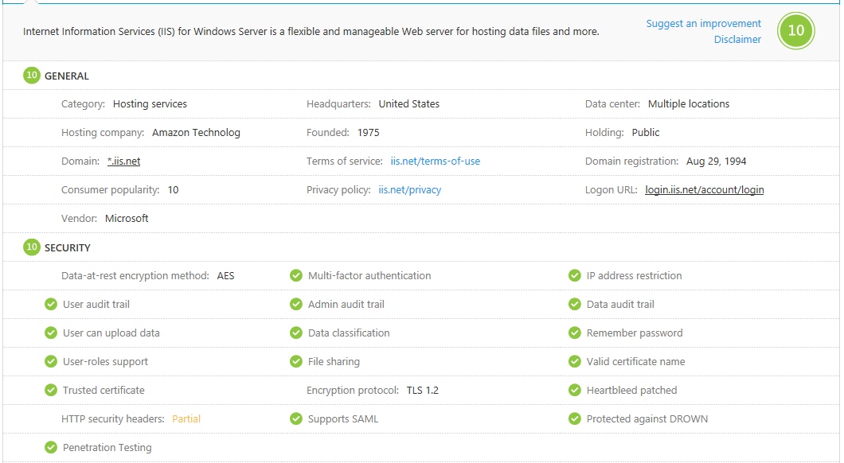

1. Then click **IP addresses** tab, to view all the IP addresses, traffic used, upload, transactions and last seen that accessed discovered cloud apps.

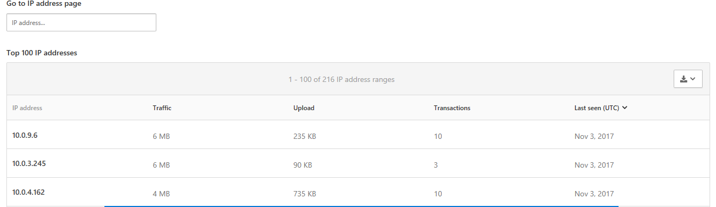

1. Click any IP address that shows the full details of that selected IP address like – Apps, risky apps, transactions, and traffic. It will also show the **Transactions chart** that displays the number of transactions recorded over the selected period of time.

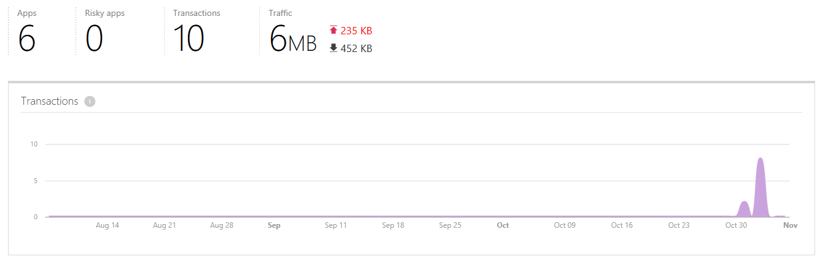

1. **Total traffic** chart displays traffic over the selected period of time.

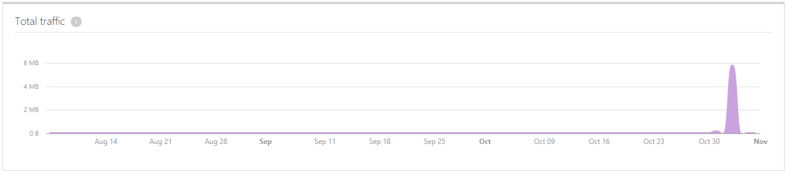

1. **Upload chart** displays upload traffic over the selected period of time.

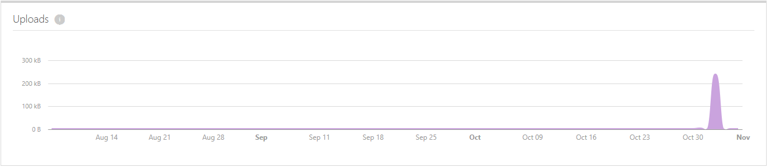

1. **Download chart** displays downloaded traffic over the selected period of time.

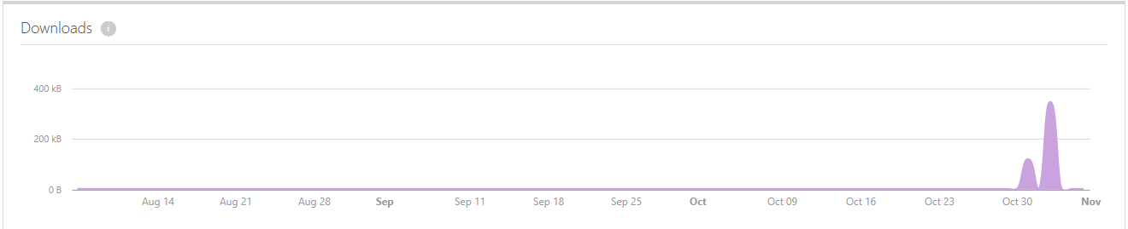

1. You can also view **discovered apps** and **User history** by clicking on their respective tabs for any specific IP address.

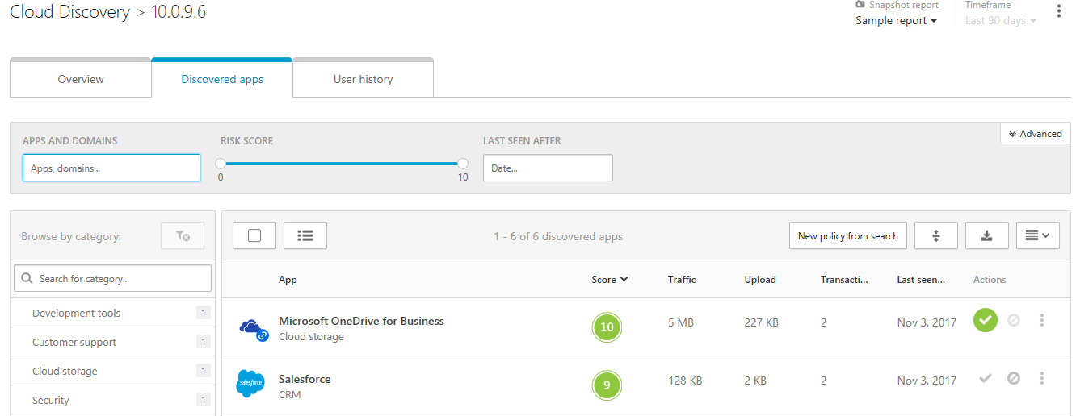

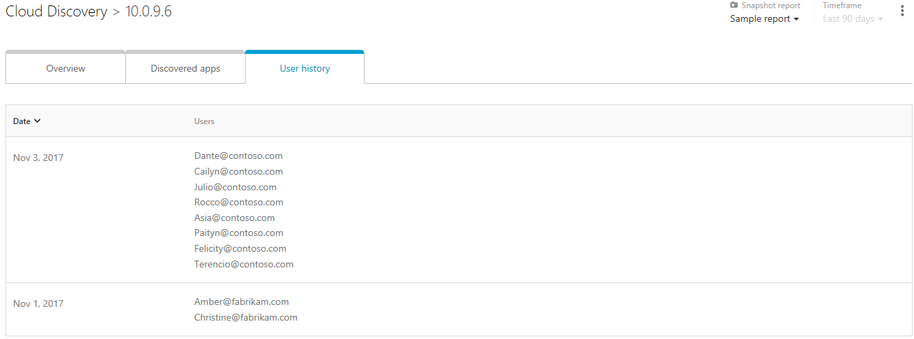

1. Then click Cloud discovery to go back to the Cloud Discovery dashboard.
2. Then click Users tab to view all the users who are using discovered cloud apps with their traffic, upload, transaction and last seen details.

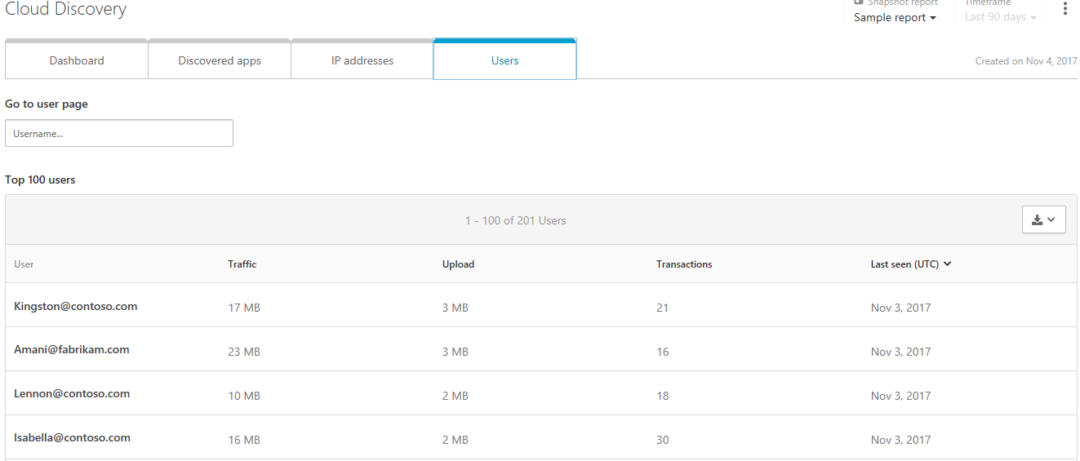

1. By clicking on any particular user, you can view the details for that user like – Apps, risky apps, transactions, and traffic. The **Transactions chart** that displays the number of transactions recorded over the selected period of time. **Total traffic chart** displays traffic over the selected period of time. **Upload chart** displays upload traffic over the selected period of time. And, **download chart** displays downloaded traffic over the selected period of time.

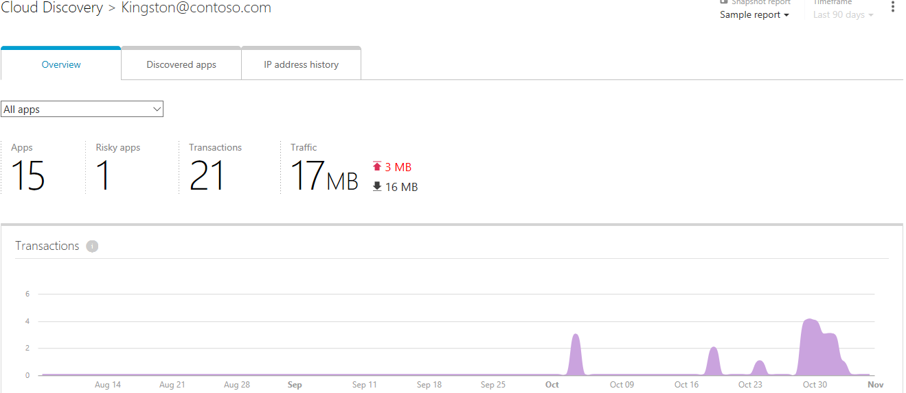

1. You can also view the discovered apps and IP address history by clicking on their respective tabs.
2. So, in this way you can use Cloud App Security and Cloud Discovery dashboard to get more insight into how cloud apps are being used in your organization and to get open alerts, activity violations, content violations, activity map and connected app usage trends in your cloud environment.